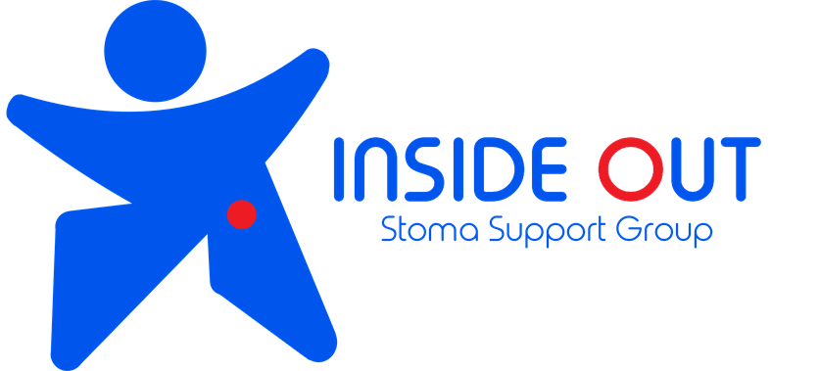
Incorporated with St Marks Hospital Foundation
Charity Registration: 1088119

31 July 2026
Welcome to Inside Out (stoma support group).

Thank you for asking for more details about Inside Out. As you may know the patients at St Marks & Northwick Park Hospital founded the group, which is run by the patients for the benefit of all stoma patients and their families, as well as those considering surgery.

Our aims are, broadly, as follows: to be self help group providing friendship and support for all stoma patients and / or their families, to keep members up to date through the newsletters and coffee mornings through out the year. On issues affecting stoma patients: to collect information about living with a stoma and to increase the public awareness of what a stoma is about.

One thing we do not want to lose track of is the fact that “living with a stoma” applies to not just the stoma patient but also their families and friends. With this in mind, our meetings are open to all patients, family and friends.

Membership.

Includes an open invitation to all our meetings and events throughout the year and quarterly newsletter, which will concentrate on a theme, such as irrigation, dealing with stomas on holiday etc. as the newsletter develops, we hope to introduce more regular slots such as readers experiences (patients & families), an “expert writes” etc. above all we want to make our newsletter interesting and helpful.

We welcome your comments about the newsletter, the support group and your suggestions for further improvements. You can write a few lines for the newsletter inviting people to contact you directly or via our address so that we may forward any messages on to you. If you require individual support for a specific problem or issue, we can put you in touch with someone who has gone through your experience and can be of help.

Funding.

The annual membership is £5.00, which is due at the beginning of the year; this can be paid by one of three ways.

- Cash
- Cheque, (made payable to St Marks Hospital Foundation / Account 101.
- Direct Debit: St Mark’s Hospital Foundation A/C 101, Lloyds Bank, Station Road, Harrow. Account: 36894268 Sort Code: 30-93-92

Yours Sincerely

Robert Lopes de Azevedo E Gilbert
(President / Co Founder Inside Out Stoma Support Group)

